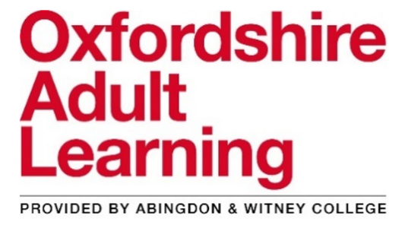
Free Family learning courses for parents starting soon
Eligibility criteria: that you have been resident in the UK or in a European Economic Area country for the past three years, are married to an EU citizen or have a parent, brother/sister or child who has been resident for three years.
All courses will be taught online on Microsoft Teams

Story writing with your child (three sessions) – Tuesday 24th November, Tuesday 1st December, Tuesday 8th December – 9.30am to 11.30am
- Write picture books using rhyme and repetition
- Experience twenty creative writing activities to tell stories
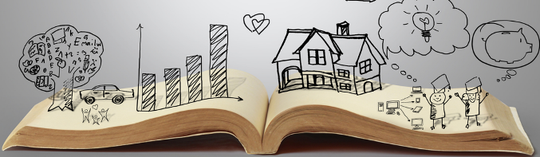
- Learn to use characters, settings, problems and resolutions to make up stories with your children
- Identify SPaG (spelling, punctuation & grammar) opportunities to improve children’s writing

Emotional Health: You and your family (three sessions) – Thursday 26th November, Thursday 3rd November, Thursday 10th November – 12.30pm to 2.00pm
- Developing communication and relationship skills
- Enhancing self-esteem and empathy with our children
- Understanding and responding to difficult feelings – our own and our children’s
- Taking care of our family’s emotional health & nurturing ourselves

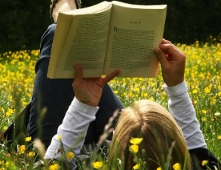
Reading with your young child (single session) – Friday 27th November from 9.30am to 11.30am
- Pre-reading skills and activities to get your child ready for reading
- How children learn to read at school
- All about phonics teaching

Emotional Health: You and your family (three sessions) – Monday 30th November, Monday 7th November, Monday 14th November – 9.30am to 11.30am
- Developing communication and relationship skills
- Enhancing self-esteem and empathy with our children
- Understanding and responding to difficult feelings – our own and our children’s
- Taking care of our family’s emotional health & nurturing ourselves
Inspiring Confidence (five sessions) – Wednesday evenings: 2nd, 9th, 16th December & 6th, 13th January – 6.30pm to 8.00pm
- Overcoming low expectations and challenging negative thoughts
- Exploring different learning styles
- Developing a positive attitude to learning in your child
- Encouraging your child to develop a growth mindset

Spontaneous storytelling (two sessions) – Friday 4th December & Friday 11th December – 9.30am to 11.30am
- The importance of storytelling in children’s development
- Experience twenty spontaneous storytelling games and activities
- Make up and tell spontaneous stories to your own children

To sign up for these free family learning courses, please contact:
Tony Payne, Family Learning Lecturer
Email: tony.payne@abingdon-witney.ac.uk

