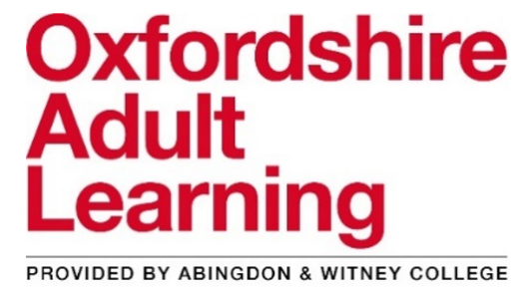
Free online family learning courses for parents to support children’s learning
provided by an experienced family learning tutor

Spontaneous storytelling (three 2-hour sessions)
- The importance of storytelling in children’s development
- Experience twenty spontaneous storytelling games and activities
- Make up and tell spontaneous stories to your own children
Story writing with your child (five 2-hour sessions)
- Write picture books using rhyme and repetition
- Experience twenty creative writing activities to tell stories
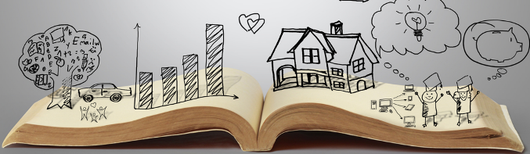
- Learn to use characters, settings, problems and resolutions to make up stories with your children
- Identify SPaG (spelling, punctuation & grammar) opportunities to improve children’s writing
Keeping up with the children in English (five 2-hour sessions)

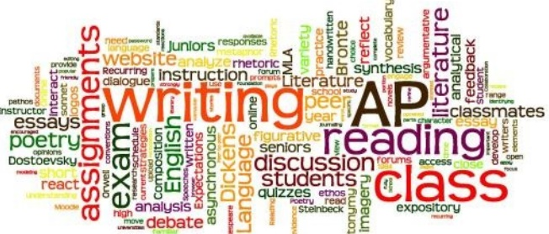
- To help parents to improve their own English, particularly in relation to everyday life
- To share ideas about how we can use everyday literacy at home to encourage our children’s learning
- To find out about and practise what is taught in English lessons in Foundation Stage, Key Stage 1 and Key Stage 2 including reading, writing and SPaG

Reading with your young child (three 2-hour sessions)

- Pre-reading skills and activities to get your child ready for reading
- Reading activities and games to play at home
- How children learn to read at school
- All about phonics teaching

Keeping up with the children in maths (five 2-hour sessions)
- To help parents to improve their own maths, particularly in relation to everyday life
- To share ideas about how we can use everyday maths at home to encourage our children’s learning
- To find out about and practise what is taught in math lessons in Foundation Stage, Key Stage 1 and Key Stage 2
ESOL class (English for speakers of other languages) (up to eight 2-hour sessions)
- To help parents to improve their English, particularly to give more confidence in spoken English
- To give parents more confidence to support their children’s learning
- To help parents to communicate with school by looking at school newsletters, school websites and by practising parent/teacher meetings
Inspiring Confidence (six 90-minute sessions)
- Overcoming low expectations and challenging negative thoughts
- Developing a positive attitude to learning in your child
- Encouraging a growth mindset in your child
- A positive approach to disciplining and supporting your child
INTERESTED?
The online sessions will be delivered via Microsoft Teams.
To express interest in a course, or for more information, please contact:
Tony Payne, Family Learning Lecturer
Email: tony.payne@abingdon-witney.ac.uk
Eligibility criteria: that you have been resident in the UK or in a European Economic Area country for the past three years, are married to an EU citizen or have a parent, brother/sister or child who has been resident for three years.

