In Phonics/Communication and language we will:
Explore letters and sounds – Aspect 2 Instrumental Sounds
Continue to use Singing phonics – Instruments
Listen to different animal sounds
Listen to stories
Learn how to follow simple instructions
(Daily)

As Mathematicians, we will:
Recap what we learnt about 2d shapes (Weeks 2 and 5)
Look at patterns (including in stories) (weekly)
Notice patterns and shapes in pictures (ABAB) (Weeks 2,4,6)
Group different objects into groups

Nursery
Topic Shines & Sparkles (Light and Dark)
Book- Night monkey day monkey
By Julia Donaldson

This term we will observe seasons and change of light to dark when autumn and winter meet.

Term - 2

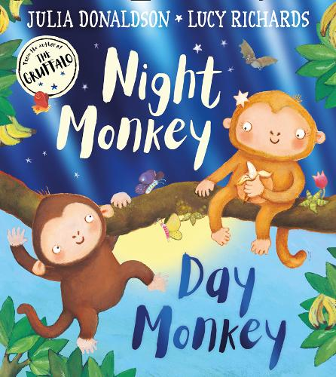
As Scientists, we will:
Make our own Glow in the dark playdough using different ingredients
Make fireworks in a jar (Week 2)
Explore why some tree’s leaves change their colours and why some doesn’t (Week 1)
Learn about nocturnal animals (Week 3)
Share our experiences (Daily)

In PE/Physical, we will:
Explore new skills that develop our gross-motor skills. (All weeks)
Continue to become confident in using the toilet independently and meeting basic health care needs. (Every day)
Continue talk about oral hygiene and why it is important. (Week 1)
Continue to take part in hand washing routines.

As Artists, we will:
Make our Diwali tealight holders using salt dough. (week 3)
Create animal footprints using paint and playdough (week 1)
Make animal masks (week 4)
Use collage to create pictures of nocturnal animals (Week 5)
Continue exploring sounds with musical instruments (Weekly)

Personal, Social and Emotional Development:

We will select and use activities and resources (with adult help when needed)
We will talk about what friendship means and what makes a good friend (week 5)
We will increasingly follow rules and will began to understand why they are important (Daily)
We will talk about how to keep safe at home and outdoors. (Week 4)
(weekly activities in group times)

As Readers and Writers, we will:

Continue to practise writing our name independently. (Daily settling task)
Engage in extended conversations about stories, learning new vocabulary. (Daily)
Begin take part in daily phonics sessions following the ‘Singing Phonics’ session.
Sing a large repertoire of songs using our music school and the Royal college of music sessions. (Weekly)

